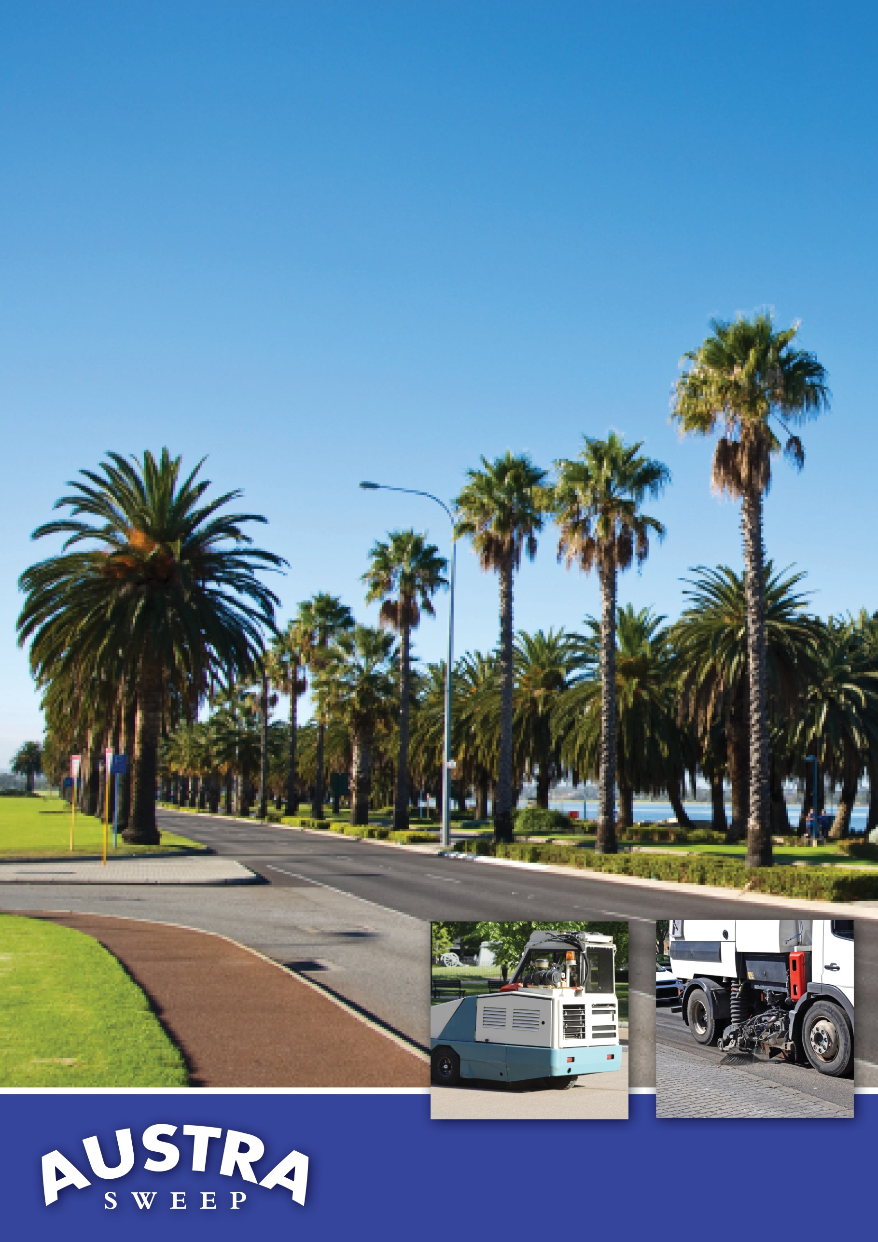

2012 Equipment  
Supply Tender

City of Canning Council Committee  
Austra Sweep AS1432

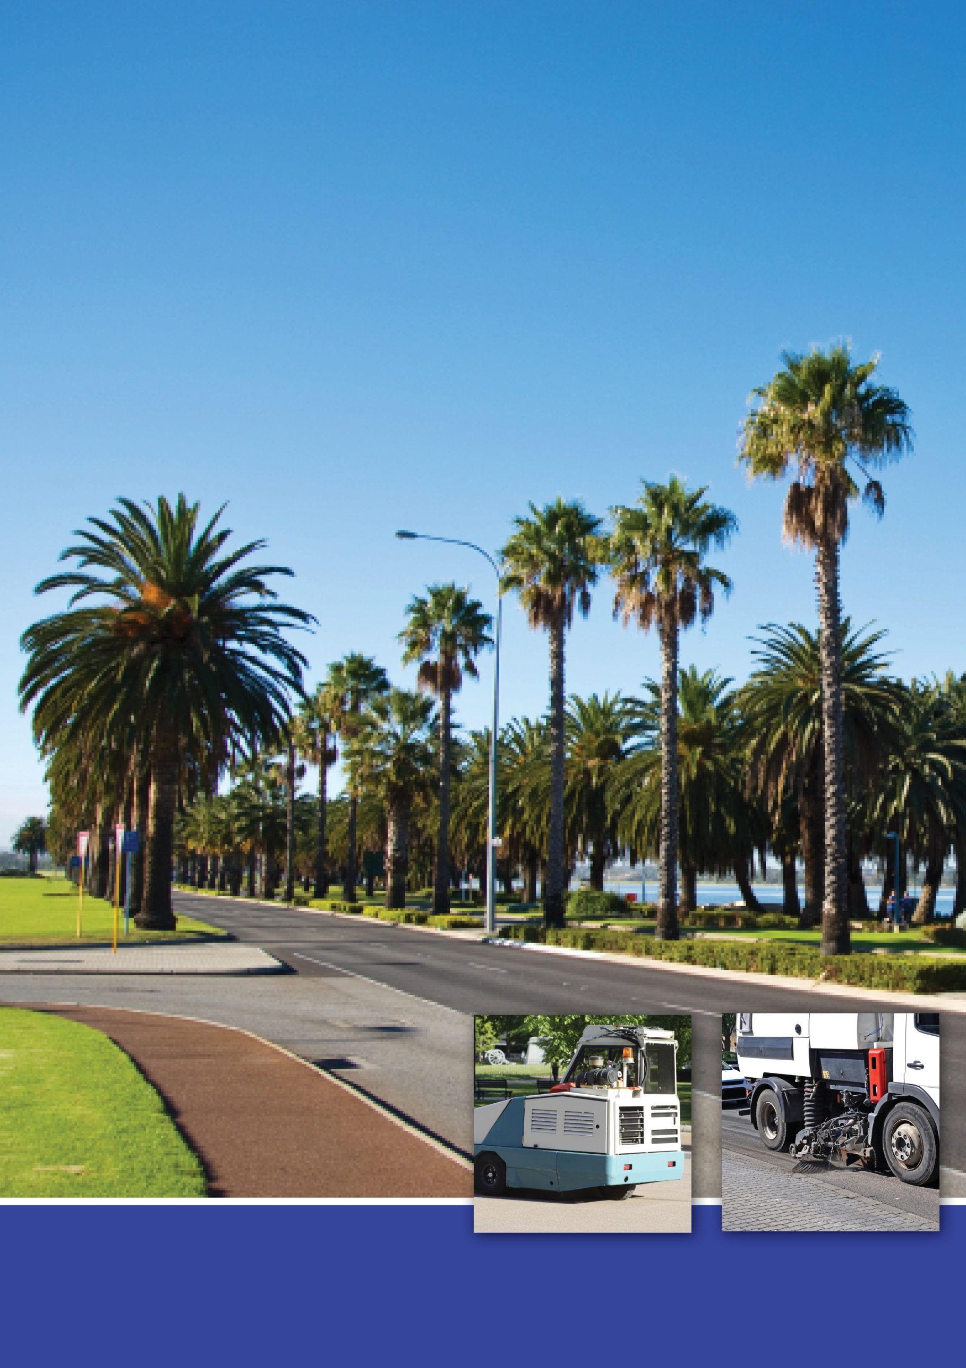

2012 Equipment  
Supply Tender

City of Canning Council Committee  
Austra Sweep AS1432